**FIN567 Financial Risk Management Homework 5**

Group name: SSVJ

Group members:

HOU Sunjie shou10

GADDA Veeraj gadda2

HONG Sungwook hong85

YOON Joonha joonhay2

Solutions:

Question 1a:

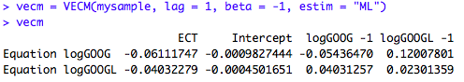

Question 1b:



Question 1c:

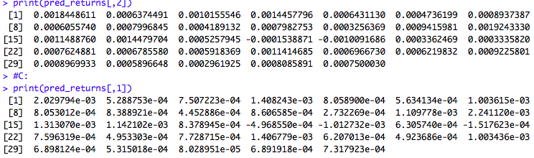

Question 2:

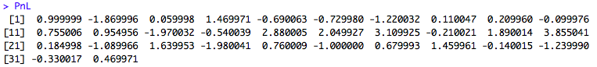

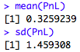

Question 3a:

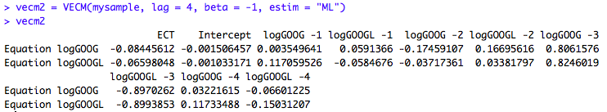

Question 3b:

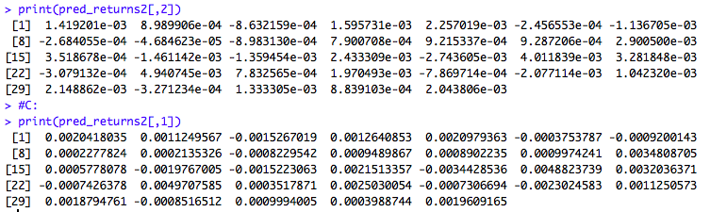

Question4:

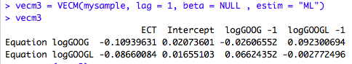,

where the cointegrating vector is (1, -0.9677).

